**Unleash Creative Control: Lighting Features in VisCommerce's 3D Room Planner**

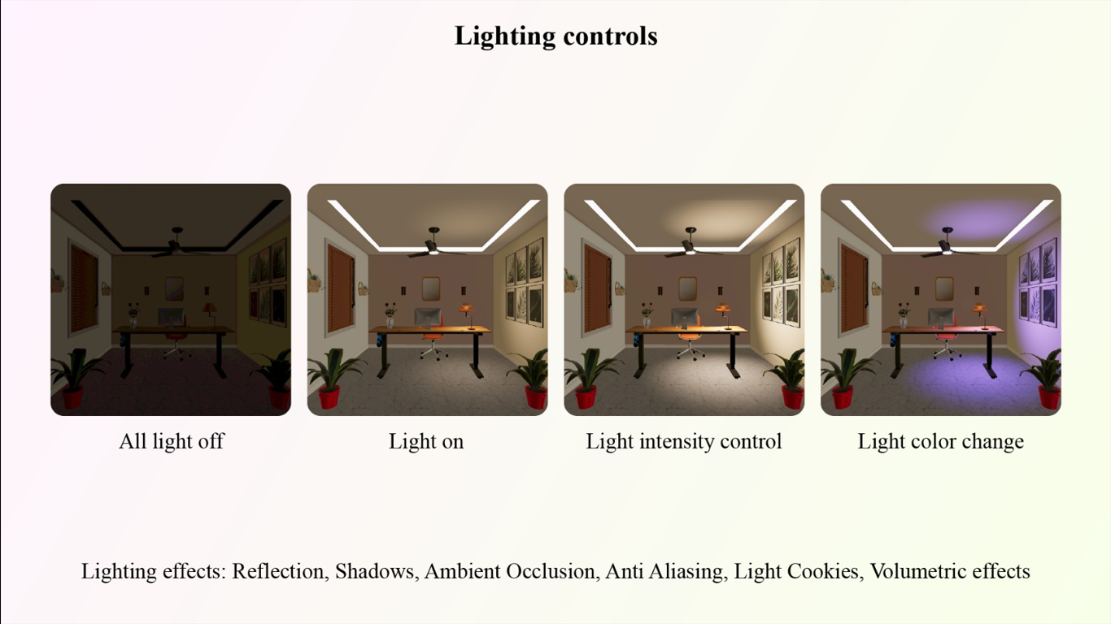

Subject: Unleash Creative Control: Lighting Features in VisCommerce's 3D Room Planner

Dear [Recipient's Name],

I hope this email finds you well. I am excited to delve into the powerful lighting capabilities that VisCommerce's 3D Room Planner brings to the table. These lighting features offer an extraordinary level of control, enabling us to create captivating and realistic visualizations within both home and store 3D environments.

In today's digital landscape, providing an immersive and lifelike experience is crucial for engaging customers effectively. The advanced lighting controls in VisCommerce's 3D Room Planner empower us to achieve this by offering a range of functionalities that shape the ambiance, mood, and realism of our visual presentations. Here's a glimpse of what these lighting features encompass:

* **Lighting Modes:** The ability to switch between various lighting modes - such as all lights off, all lights on, and light intensity control - allows us to showcase products in different scenarios. Customers can assess how our offerings look in both well-lit conditions and intimate settings, aiding their decision-making process.
* **Dynamic Light Color Changes:** With the power to change light colors, we can demonstrate how different lighting hues can influence the atmosphere of a room. This feature enables us to present products in various lighting scenarios and show how they adapt to different color temperatures.
* **Lighting Effects and Shadows:** The inclusion of lighting effects and shadows adds a layer of depth and realism to our presentations. By leveraging these features, we can accentuate textures, shapes, and dimensions, making our products feel more tangible and inviting.
* **Reflection and Ambient Occlusion:** These features contribute to a heightened sense of realism by mimicking how light interacts with surfaces and how ambient light is occluded in crevices. This level of detail elevates the overall visual quality of our presentations.
* **Anti-Aliasing:** The incorporation of anti-aliasing ensures that the edges of objects appear smooth and natural, reducing jaggedness and enhancing the visual appeal of our 3D environments.
* **Light Cookies and Volumetric Effects:** Light cookies allow for intricate light shaping, while volumetric effects simulate the behavior of light in a more realistic manner, enhancing the depth and immersion of our visualizations.

The incorporation of these lighting features equips us with the tools to create impactful and engaging presentations that resonate with our customers. From realistic shadows to dynamic light color changes, each aspect contributes to a holistic and immersive shopping experience.

Should you be interested in exploring these lighting features further, I'd be delighted to provide additional insights or arrange a demonstration. The possibilities that VisCommerce's 3D Room Planner brings to our product presentation strategies are truly boundless.

Thank you for your time, and I eagerly await your thoughts.

Best regards,